Harlow, Justin F
4.20.26
PHYS 450
Enriched Exoplanet and Host Star Catalog for Data Analysis
Abstract:
This study presents a clean and enriched dataset of 6,059 confirmed exoplanets and their host stars. Missing planetary and stellar parameters were supplemented using the NASA Exoplanet Archive PSComppars table, while missing stellar spectral classifications were recovered through SIMBAD host-star matching. For stars without observed spectral classifications, spectral type was estimated to use effective temperature, surface gravity, and stellar radius. The completed dataset was used to examine orbital period, orbital distance, planetary radius, planetary mass, equilibrium temperature, stellar mass, stellar radius, stellar effective temperature, and host-star spectral class. The resulting visualizations reveal strong clustering of detected exoplanets at short orbital periods and small orbital distances, reflecting both physical trends and observational selection effects. Host stars are primarily concentrated among F, G, K, and M spectral classes. While derived spectral classifications increase dataset completeness, they remain approximate and should be interpreted as model-based estimates. Overall, the enriched dataset provides a useful foundation for exoplanet population analysis, host-star comparison, and future statistical studies.

1. Introduction
The discovery and characterization of exoplanets has become one of the most rapidly expanding fields in modern astrophysics. Since the first confirmed detections of planets orbiting stars beyond the Solar System, thousands of exoplanets have been identified across a wide range of stellar environments. These discoveries provide insight into planetary formation, orbital evolution, stellar planet interactions, and the diversity of planetary systems throughout the galaxy.
Exoplanet population studies are important because they allow researchers to move beyond individual discoveries and investigate statistical trends across large samples. By examining distributions of orbital properties, planetary sizes, masses, thermal environments, and host-star characteristics, researchers can identify large-scale patterns that inform theoretical models of planet formation and migration.
Key variables in exoplanet population analysis include orbital period, orbital distance, planetary radius, planetary mass, equilibrium temperature, and host-star properties such as stellar mass, radius, effective temperature, luminosity class, and spectral classification. Together, these parameters provide a multidimensional framework for understanding how planetary systems form and evolve under different stellar conditions.

2. Dataset and Sources
The original dataset used in this study contained 6,059 confirmed exoplanets and associated host-star properties after being cleaned from approximately 35000 data entries. Because many entries contained incomplete stellar or planetary measurements, a multi-stage enrichment pipeline was developed to improve dataset completeness while preserving data provenance.
The dataset was enriched using three primary sources:
- NASA Exoplanet Archive PSComppars Table
Used to supplement missing planetary and stellar parameters including orbital period, orbital distance, planetary radius, planetary mass, equilibrium temperature, stellar effective temperature, stellar radius, stellar mass, surface gravity, and distance.
- SIMBAD Astronomical Database
Used to recover missing stellar spectral classifications through host-star identifier matching and alias resolution.
- Derived Stellar Classification Methods
Used when observed spectral classifications were unavailable. Spectral type and luminosity class were estimated from stellar effective temperature, stellar radius, and stellar surface gravity using rule-based astrophysical approximations.
Incomplete rows were retained whenever possible to maximize statistical sample size. As a result, the number of observations included in each graph varies depending on the availability of the required variables. This approach preserves the largest possible dataset while avoiding exclusion of partially complete but scientifically useful entries.

3. Data Cleaning and Enrichment Methods
The original exoplanet dataset contained missing values across multiple planetary and stellar parameters. To improve completeness while maintaining scientific reliability, a multi-stage enrichment workflow was developed. The process combined external astronomical databases, automated querying, structured matching procedures, and derived stellar classification methods. All enrichment steps were performed programmatically using Python within a Jupyter Notebook environment to ensure reproducibility and transparency.
The enrichment pipeline followed three primary stages:
- NASA PSComppars parameter completion
- SIMBAD stellar classification recovery
- Derived stellar spectral and luminosity classification
Each stage contributed additional information without overwriting existing observed values.

3.1 NASA PSComppars Fill
The first stage of enrichment used the NASA Exoplanet Archive PSComppars table to recover missing planetary and stellar parameters.
The PSComppars dataset provides a consolidated table of confirmed exoplanet properties, including orbital characteristics, planetary measurements, and host-star properties. A structured query was performed using the NASA Table Access Protocol (TAP) to retrieve relevant fields.
Retrieved parameters included:
- Orbital Period [Days]
- Orbit Semi-Major Axis [AU]
- Planet Radius [Earth Radius]
- Planet Mass or Mass·sin(i) [Earth Mass]
- Equilibrium Temperature [K]
- Stellar Effective Temperature [K]
- Stellar Radius [Solar Radius]
- Stellar Mass [Solar Mass]
- Stellar Surface Gravity [log10(cm/s²)]
- Distance [pc]
The NASA dataset was merged with the original spreadsheet using planet name as the primary matching key.
Only missing values in the original dataset were replaced. Existing observed measurements were preserved to avoid overwriting source data.
This approach improved completeness while maintaining data provenance and minimizing unnecessary modification of original observations.

3.2 SIMBAD Fill
Following NASA enrichment, many host stars still lacked spectral classifications. To address this, the SIMBAD Astronomical Database was queried using Astroquery. SIMBAD is a curated astronomical object database that aggregates stellar identifiers, classifications, aliases, and catalog cross-references.
Host-star names were extracted from the dataset and matched against SIMBAD entries using batch queries. Because stellar objects frequently possess multiple identifiers, direct name matching alone is often insufficient. Therefore, a flexible matching strategy was implemented.
Matching considered:
- Primary SIMBAD identifier
- Alternate aliases
- Catalog cross-references
- Compact normalized name forms
Host-star names were normalized through:
- Uppercase conversion
- Removal of punctuation
- Removal of whitespace
- Alias comparison
This normalization reduced mismatch errors caused by formatting differences.
Recovered SIMBAD spectral classifications were inserted only when the original spectral type field was missing.
This stage significantly increased spectral-type completeness while preserving observational priority.

3.3 Derived Stellar Classification
Even after NASA and SIMBAD enrichment, some stars still lacked spectral classification. To increase completeness, a rule-based derivation system was implemented.
Derived classification relied on known stellar astrophysical relationships linking temperature, radius, gravity, and stellar evolutionary stage.
The derivation process estimated:
- Spectral letter class (O–M)
- Spectral subclass (0–9)
- Luminosity class (I–V)
Derived classifications were only used when no observed or SIMBAD classification existed.

3.4 Spectral Type Derivation
Spectral classification was estimated primarily from stellar effective temperature.
Temperature ranges were mapped to standard stellar spectral classes:
Spectral Class | Approximate Temperature Range (K)
O | > 30,000
B | 10,000–30,000
A | 7,500–10,000
F | 6,000–7,500
G | 5,200–6,000
K | 3,700–5,200
M | < 3,700
Once a letter class was assigned, a subclass value (0–9) was estimated through interpolation within the temperature interval.
For example:
- 5950 K → G1–G2
- 5750 K → G3–G5
- 5300 K → G8–G9
This produced finer classifications such as:
- G2
- K4
- F8

3.5 Luminosity Class Derivation
Luminosity class describes the evolutionary state of the star.
Luminosity estimation used:
- Stellar surface gravity (log g)
- Stellar Radius
Approximate luminosity rules included:
log(g) | Luminosity Class
≥ 4.0 | V (Main Sequence)
3.0–4.0 | IV (Subgiant)
1.5–3.0 | III (Giant)
< 1.5 | I (Supergiant)
When surface gravity was unavailable, stellar radius was used as a fallback estimator.
Radius thresholds included:
Radius (Solar Radii) | Luminosity Class
≤ 1.8 | V
≤ 4 | IV
≤ 20 | III
> 20 | I

3.6 Final Classification Hierarchy
To preserve observational reliability, spectral types followed a priority hierarchy:
- Original observed spectral classification
- SIMBAD spectral classification
- Derived spectral classification
- Null value when insufficient information existed
This hierarchy ensured that measured values always superseded inferred values.

3.7 Reproducibility and Provenance Tracking
All enrichment procedures were implemented programmatically using Python and Jupyter Notebook.
This provides several advantages:
- Reproducibility
- Transparent methodology
- Automated reprocessing
- Independent verification
- Scalable updates for future datasets

3.8 Astroquery and Automated Astronomical Database Integration
A major component of this study involved the automated retrieval of missing stellar and planetary parameters using the Python package Astroquery. Astroquery provides a programmatic interface to astronomical databases and archives, enabling researchers to query external repositories directly within a reproducible scientific workflow.
In this project, Astroquery was used to connect with the SIMBAD Astronomical Database, maintained by the Centre de Données astronomiques de Strasbourg (CDS). SIMBAD provides cross-referenced stellar identifiers, spectral classifications, catalog aliases, and additional stellar metadata.
The use of Astroquery provides several advantages for large-scale astronomical data analysis:
- Eliminates manual database lookup
- Supports automated batch processing
- Ensures reproducibility of results
- Enables cross-catalog matching of astronomical objects
- Reduces transcription and human-entry errors
- Integrates directly with Jupyter Notebook workflows
Rather than manually searching thousands of stellar hosts, Astroquery enabled automated retrieval of stellar classifications through a repeatable and scalable pipeline.

3.9 Code Workflow and Data Processing Pipeline
The data enrichment workflow was implemented entirely in Python using Jupyter Notebook. Python was selected due to its extensive ecosystem for scientific computing, tabular analysis, and astronomical database access.
The enrichment pipeline consisted of three major stages:
- NASA Exoplanet Archive enrichment
- SIMBAD stellar classification retrieval
- Stellar spectral and luminosity derivation
The overall workflow can be summarized as:
Original Dataset → NASA Fill → SIMBAD Fill → Derived Stellar Classification → Final Publication Dataset
This pipeline ensured that missing values were supplemented progressively while preserving existing observational measurements.

3.9.1 Python Libraries Used
Library | Purpose
pandas | Data loading, cleaning, merging, filtering
astroquery | Astronomical database access
openpyxl | Excel formatting and provenance highlighting
matplotlib | Data visualization and plotting
numpy | Numerical operations
Jupyter Notebook | Interactive scientific workflow environment

3.9.2 Data Loading
The original dataset was imported into a Pandas DataFrame from Excel format:
import pandas as pd
df = pd.read_excel("Exoplanet_6059-b.xlsx")
Pandas enabled manipulation of planetary and stellar parameters in tabular form, supporting filtering, matching, missing-value handling, and derived-variable generation.

3.10 NASA Exoplanet Archive Data Fill
The NASA Exoplanet Archive PSComppars table was queried using the Table Access Protocol (TAP). A structured SQL-style query retrieved planetary and stellar parameters relevant to exoplanet characterization.
Example query:
SELECT
pl_name,
hostname,
pl_orbper,
pl_orbsmax,
pl_rade,
pl_bmasse,
pl_eqt,
st_spectype,
st_teff,
st_rad,
st_mass,
st_logg,
sy_dist
FROM pscomppars
Retrieved parameters included:
- Orbital Period
- Orbital Distance
- Planet Radius
- Planet Mass
- Equilibrium Temperature
- Stellar Effective Temperature
- Stellar Radius
- Stellar Mass
- Surface Gravity
- Distance
The NASA dataset was merged with the original spreadsheet using planet name as the primary matching key.
Only missing values were supplemented, ensuring that existing measurements remained unchanged.

3.11 SIMBAD Querying Through Astroquery
Following NASA enrichment, missing stellar spectral classifications were recovered using SIMBAD through Astroquery.
Example implementation:
from astroquery.simbad import Simbad
custom_simbad = Simbad()
custom_simbad.add_votable_fields("sp_type", "ids")
Unique host-star names were extracted and queried in batch form:
hosts = df["Host Name"].dropna().unique().tolist()
simbad_results = custom_simbad.query_objects(hosts)
Batch querying improved efficiency by allowing thousands of stellar hosts to be queried simultaneously.
Returned SIMBAD fields included:
- MAIN_ID
- SP_TYPE
- IDS
These fields enabled cross-reference matching using aliases and alternate catalog identifiers.

3.12 Host Star Matching Strategy
Astronomical objects frequently possess multiple catalog identifiers.
Examples include:
- HD catalog
- HIP catalog
- Gaia identifiers
- TIC identifiers
- TOI identifiers
- 2MASS identifiers
To improve matching reliability, host-star names were normalized prior to comparison.
Normalization included:
- Uppercase conversion
- Removal of whitespace
- Removal of punctuation
- Alias matching
Example:
"HD 209458" → "HD209458"
Matching logic compared:
- Primary SIMBAD identifier
- Alias identifiers
- Compact normalized identifiers
This process improved cross-catalog consistency and increased successful spectral-type recovery.

4. Graphs and Analysis
The enriched exoplanet dataset was analyzed through a series of statistical visualizations designed to examine planetary distributions, host-star properties, and relationships between orbital, thermal, and stellar parameters. Each graph focuses on a specific astrophysical relationship or population trend. Because missing values vary by parameter, the number of observations included in each figure differs according to data availability.
List of graphs in this report;
Orbital Period Distribution, Orbital Distance Distribution, Planet Radius vs. Mass, Orbital Period vs. Mass, Orbital Distance vs. Mass, Radius vs. Orbital Period, Radius vs. Equilibrium Temperature, Mass vs. Equilibrium Temperature, Orbital Distance vs. Equilibrium Temperature, Host Star Mass Distribution, Host Star Radius Distribution, Host Star Effective Temperature Distribution, H-R Diagram of Exoplanet Host Stars Planet Radius by Host Star Spectral Class, Spectral Class Distribution, Final Spectral Type Source, Number of Exoplanets by Discovery Method.
4.1 Orbital Period Distribution
This histogram illustrates the distribution of orbital periods across confirmed exoplanets.
Orbital period represents the time required for a planet to complete one orbit around its host star. The distribution is strongly skewed toward short-period planets, reflecting both physical clustering and observational selection effects.
Most confirmed exoplanets are concentrated at short orbital periods, particularly below several hundred days. This trend is largely influenced by detection methods such as transit photometry and radial velocity surveys, which are more sensitive to close-in planets.
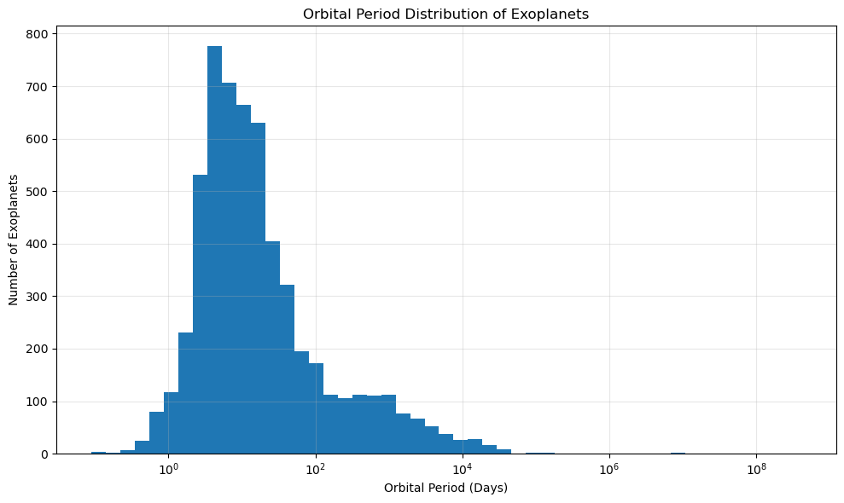

4.2 Orbital Distance Distribution
This histogram shows the distribution of orbital semi-major axes for exoplanets.
Orbital distance provides insight into planetary system architecture and migration history. Most detected planets occupy small orbital separations from their host stars.
A strong concentration near small orbital distances is expected because short-distance planets produce stronger transit signals and larger radial velocity signatures.

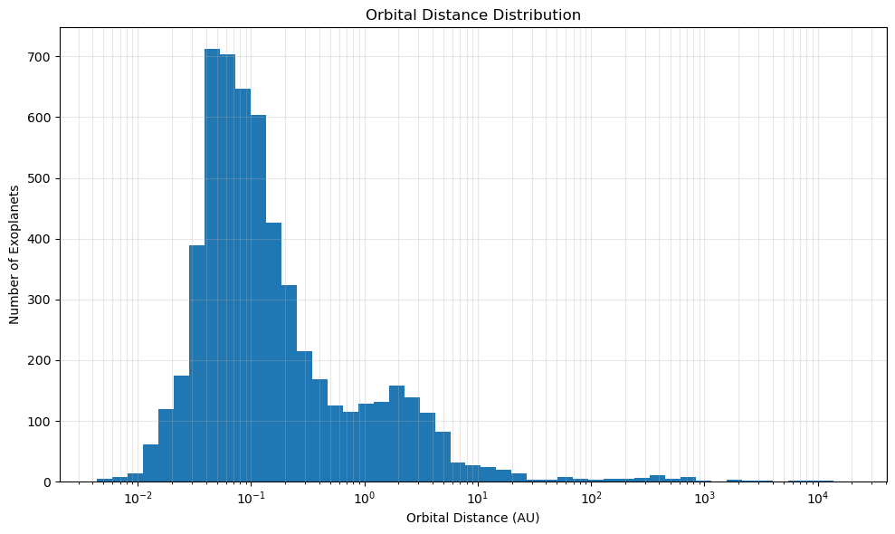

4.3 Planet Radius vs. Mass
This scatter plot compares planetary radius and planetary mass.
A positive relationship generally exists between radius and mass; however, substantial scatter is observed because planetary density varies significantly among gas giants, rocky planets, and intermediate sub-Neptune populations.
Logarithmic scaling is applied to reveal structure across multiple planetary regimes.

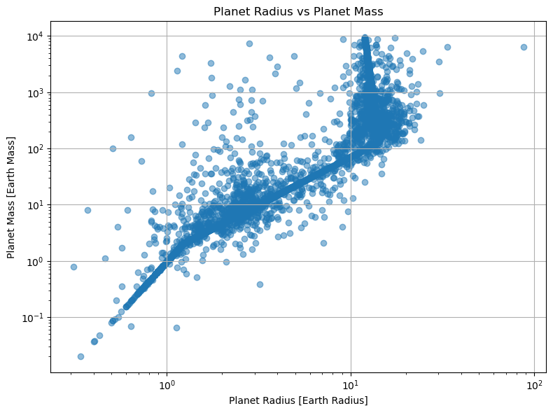

4.4 Orbital Period vs. Mass
This graph compares orbital period with planetary mass.
The relationship highlights how planetary mass is distributed across orbital timescales. Certain massive planets appear preferentially at short orbital periods due to detection bias and the prevalence of hot Jupiters.
The plot also reveals broad dispersion, indicating that planetary mass alone does not uniquely determine orbital configuration.
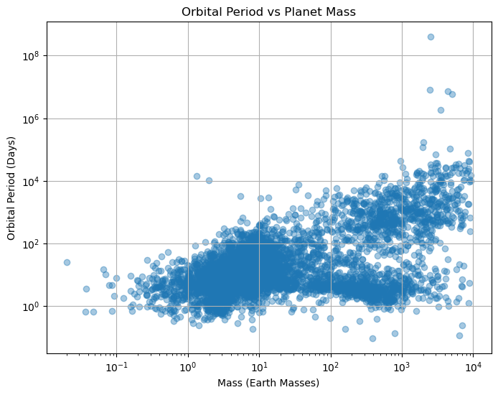

4.5 Orbital Distance vs. Mass
This scatter plot examines the relationship between planetary mass and orbital separation.
Massive planets appear across a wide range of orbital distances. However, detection efficiency strongly favors massive planets located close to host stars.
Long-period giant planets remain underrepresented because they require extended observation times.
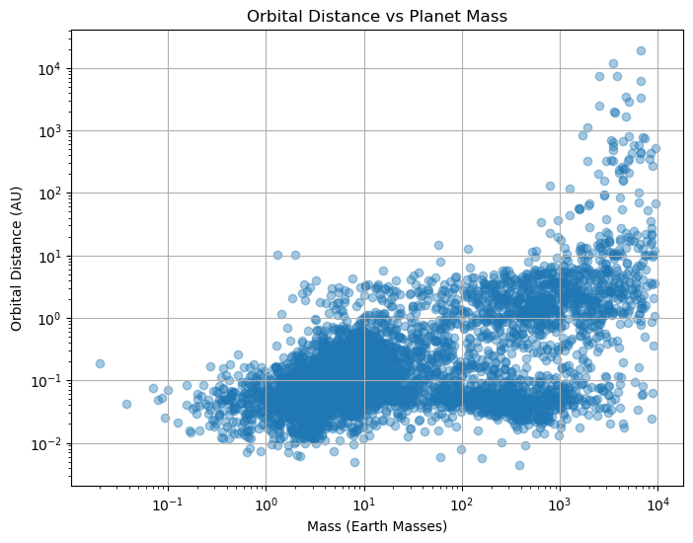

4.6 Radius vs. Orbital Period
This graph investigates how planetary radius varies with orbital period.
Short-period planets often display a wide range of radii, including inflated gas giants and compact rocky planets.
This figure may reveal clustering among hot Jupiters and compact multi-planet systems.

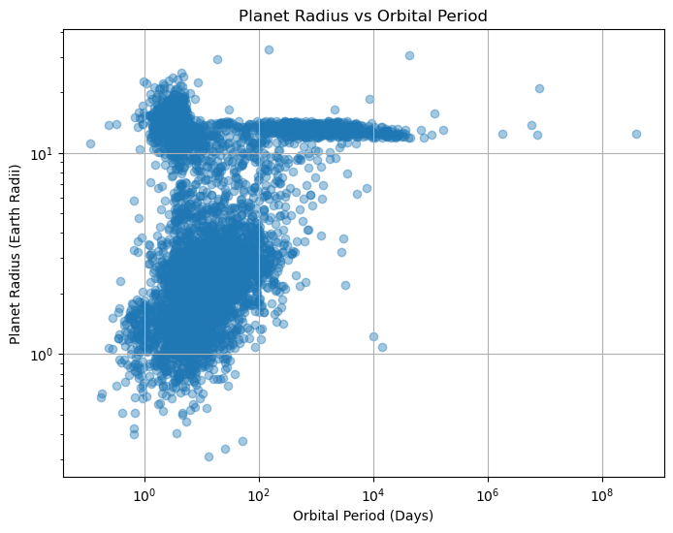

4.7 Radius vs. Equilibrium Temperature
This scatter plot compares planetary radius with equilibrium temperature.
Equilibrium temperature estimates the thermal environment of a planet based on stellar radiation and orbital distance.
Large-radius planets at high temperatures may indicate atmospheric inflation effects caused by intense stellar irradiation.
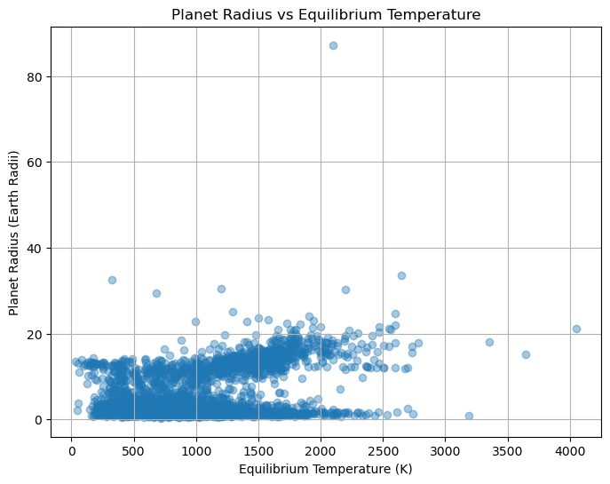

4.8 Mass vs. Equilibrium Temperature
This graph compares planetary mass and equilibrium temperature.
Massive planets occur across a wide temperature range, though close-in gas giants often occupy high-temperature environments.
The relationship provides insight into atmospheric retention, irradiation effects, and planetary migration.
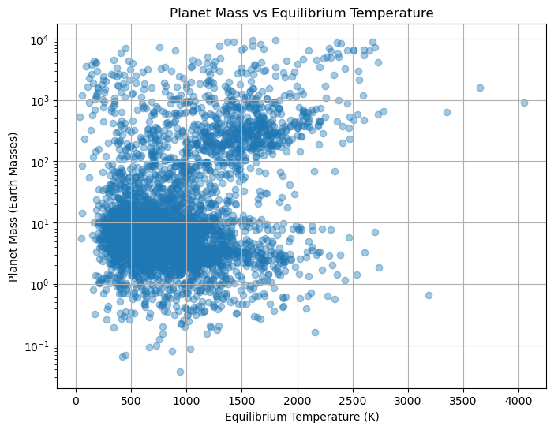

4.9 Orbital Distance vs. Equilibrium Temperature
This graph explores the inverse relationship between orbital separation and equilibrium temperature.
Planets closer to their host stars generally experience higher equilibrium temperatures.
This relationship is expected from radiative flux scaling and provides a consistency check for orbital and thermal parameters.

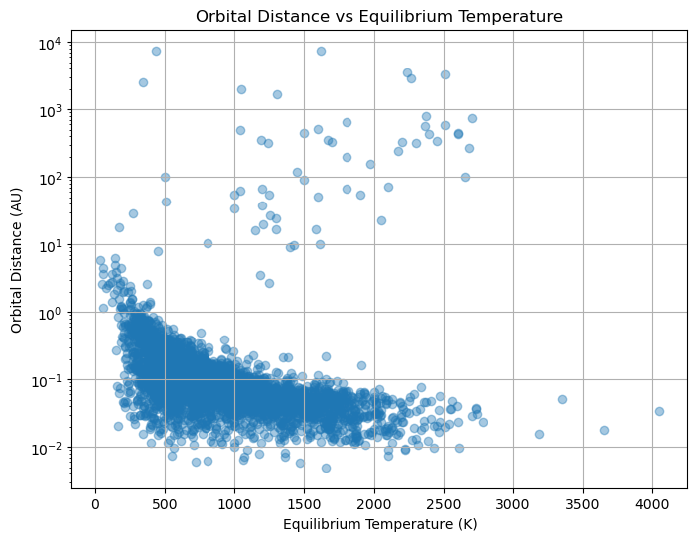

4.10 Host Star Mass Distribution
This scatter plot displays the distribution of host-star masses.
Host-star mass is a fundamental property influencing stellar luminosity, lifespan, and planetary formation processes.
The exoplanet host sample is expected to cluster near solar-mass stars due to observational targeting biases.
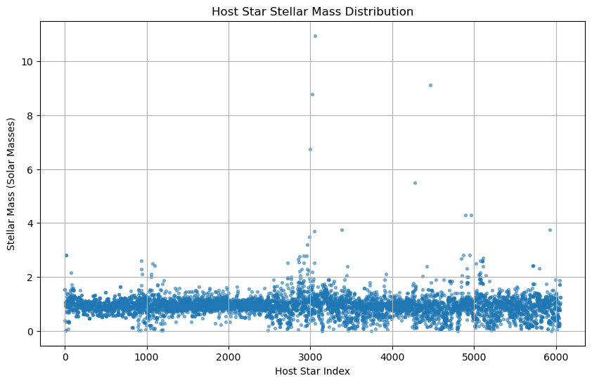

4.11 Host Star Radius Distribution
This figure illustrates stellar radius values among host stars.
Radius distributions help identify evolutionary populations such as main-sequence stars, subgiants, and giants.
Logarithmic scaling improves visibility across multiple stellar regimes.
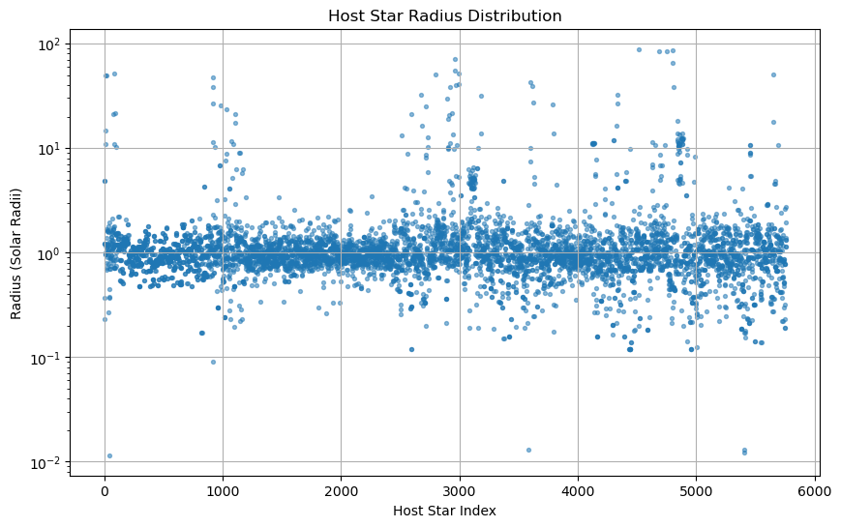

4.12 Host Star Effective Temperature Distribution
This scatter plot shows stellar effective temperatures for host stars.
Temperature distributions provide insight into stellar spectral populations.
Most exoplanet host stars are expected to cluster within F-, G-, K-, and M-type temperature ranges.

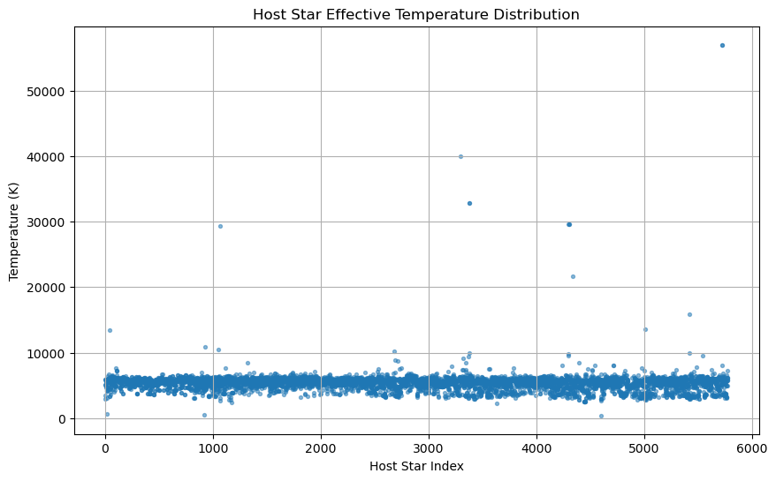

4.13 H-R Diagram of Exoplanet Host Stars
The Hertzsprung–Russell (H-R) diagram compares stellar effective temperature and luminosity.
This graph is one of the most important stellar population tools in astrophysics.
The H-R diagram allows visualization of:
- Main-sequence host stars
- Subgiants
- Giant stars
- Stellar evolutionary pathways
Luminosity was derived using stellar radius and temperature:
$$L∝R^{2}T^{4}$$
The exoplanet host population is expected to concentrate heavily on the main sequence.
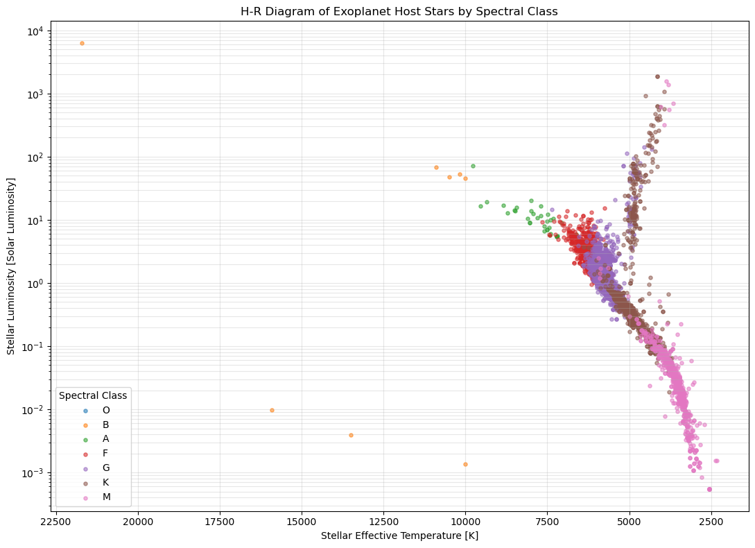

4.14 Planet Radius by Host Star Spectral Class
This box plot compares planetary radius distributions across host-star spectral classes.
Different stellar populations may preferentially host different planetary size regimes.
Comparisons across spectral class may reveal whether larger planets preferentially orbit hotter or more massive stars.

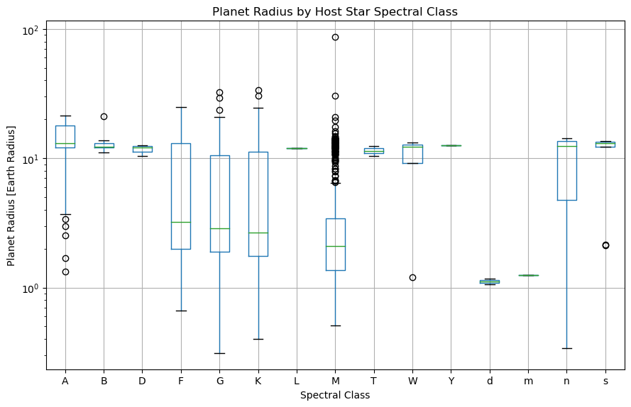

4.15 Spectral Class Distribution
This histogram displays the frequency of host-star spectral classifications.
Spectral classes provide a simplified classification of stellar temperature and color.
Most exoplanet hosts are expected to fall within:
- F-type
- G-type
- K-type
- M-type
This distribution reflects both stellar abundance and observational targeting strategies.
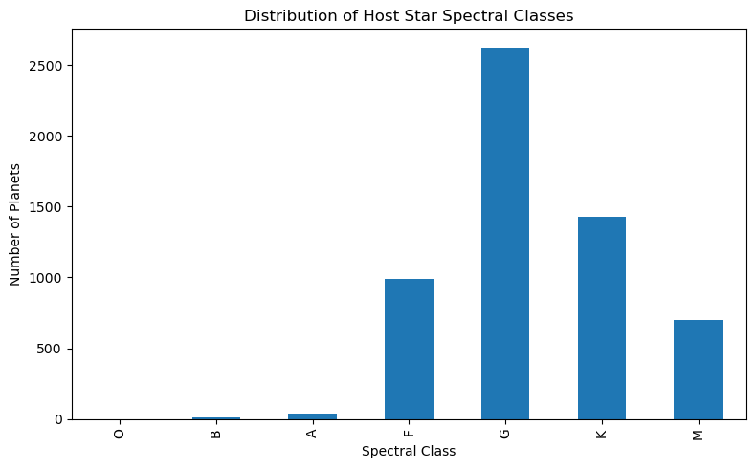

4.16 Final Spectral Type Source
This chart identifies the origin of the final spectral classification.
Categories include:
- Original observed classification
- SIMBAD-derived classification
- Derived classification from astrophysical estimation
This figure quantifies the contribution of each enrichment stage.

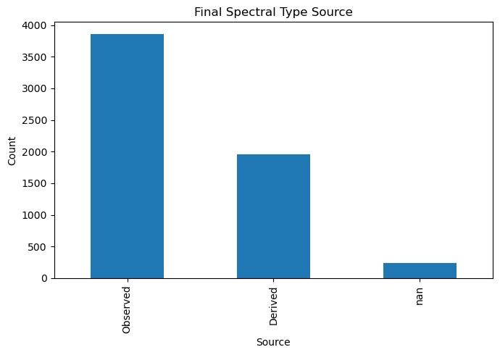

4.17 Number of Exoplanets by Discovery Method
This graph compares exoplanet counts across detection techniques.
Common discovery methods include:
- Transit
- Radial Velocity
- Imaging
- Microlensing
- Timing Variations
Transit detection is expected to dominate modern exoplanet catalogs due to large survey missions such as NASA's Kepler Space Telescope and Transiting Exoplanet Survey Satellite.
This figure highlights the observational biases present in current exoplanet discovery catalogs.
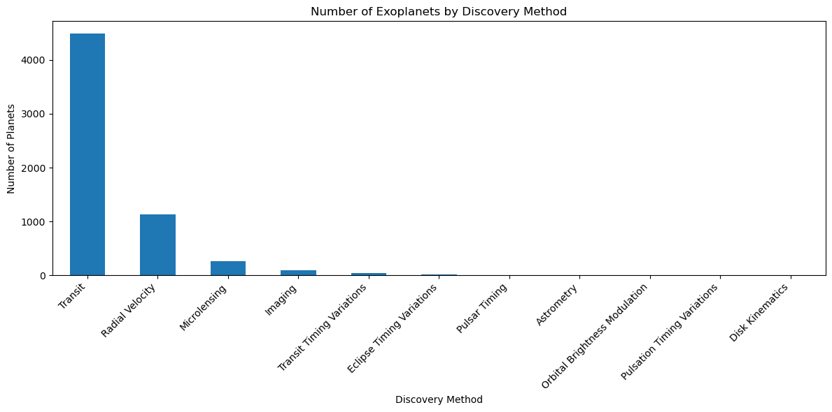

5. Discussion
The visual analysis of the enriched exoplanet dataset reveals several significant trends within the currently known exoplanet population. Histograms of orbital period and orbital distance demonstrate that the majority of confirmed exoplanets are located close to their host stars and complete orbits on relatively short timescales. This concentration of short period systems is consistent with the observational biases associated with dominant discovery techniques such as transit photometry and radial velocity detection, both of which are more sensitive to planets orbiting near their host stars.
The orbital period and orbital distance distributions suggest that compact planetary systems are strongly represented within confirmed exoplanet catalogs. Many planets occupy orbital separations substantially smaller than those observed within the Solar System. While this trend partly reflects real astrophysical populations, it is also influenced by the relative ease of detecting planets that transit frequently or induce measurable stellar motion.
Scatter plots comparing planetary radius, mass, orbital period, orbital distance, and equilibrium temperature reveal broad correlations across planetary populations. Radius and mass exhibit an overall positive relationship; however, the distribution contains substantial scatter. This dispersion reflects variations in planetary density and internal composition. Rocky terrestrial planets, water-rich worlds, ice giants, and gas giants occupy overlapping but distinct parameter regions. Planets of similar radius may possess dramatically different masses depending on atmospheric thickness, core composition, and formation history.
Orbital relationships further show that close-in planets often experience elevated equilibrium temperatures due to strong stellar irradiation. This is particularly evident in hot Jupiter populations, which combine short orbital distances, high equilibrium temperatures, and large planetary radii. Atmospheric inflation may contribute to the enlarged radii observed among highly irradiated gas giants.
The radius versus period and mass versus period relationships also suggest clustering among short-period planetary populations. Hot Jupiters, warm Neptunes, and compact super-Earth systems appear preferentially within low-period regions. These patterns are consistent with migration theories in which giant planets move inward through disk interactions or dynamical scattering.
Host-star distributions indicate that most confirmed exoplanets orbit stars belonging to the F-, G-, K-, and M-type spectral classes. These stars dominate exoplanet catalogs because they are abundant, well-characterized, and frequently targeted by modern surveys. The concentration of host stars along the main sequence in the H-R diagram reinforces this result, indicating that exoplanet detection is most common around stable hydrogen-burning stars.
The inclusion of derived spectral classifications significantly improves dataset completeness by providing estimated classifications for previously uncharacterized stars. However, derived classifications should be interpreted as approximations rather than direct measurements. While temperature, surface gravity, and stellar radius provide reasonable indicators of spectral type and luminosity class, these estimates cannot fully replace spectroscopic observations.
Overall, the enriched dataset reveals strong evidence of both astrophysical structure and observational selection effects. The observed exoplanet population reflects not only intrinsic planetary diversity but also the limitations and sensitivities of current detection techniques.

6. Limitations
Several limitations should be considered when interpreting the results of this analysis.
First, despite enrichment through NASA PSComppars, SIMBAD retrieval, and derived classification methods, missing values remain in portions of the dataset. Certain host stars and planetary systems lack sufficient measurements to estimate all parameters reliably.
Second, derived spectral classifications are approximate. Although stellar effective temperature, radius, and surface gravity provide meaningful astrophysical constraints, derived classifications do not replace direct spectroscopic measurements. These values should therefore be interpreted as model-based estimates.
Third, the confirmed exoplanet sample is strongly influenced by observational bias. Detection techniques such as transit photometry and radial velocity methods preferentially discover large planets orbiting close to their host stars. Consequently, long-period planets, low-mass planets, and distant planetary systems are likely underrepresented.
Additionally, planetary mass values may vary depending on detection method. In radial velocity systems, reported mass often corresponds to minimum mass $Msin⁡i$, rather than true planetary mass. This introduces uncertainty when comparing planets across detection categories.
Another limitation involves catalog evolution. The NASA Exoplanet Archive and SIMBAD databases are continuously updated as new observations become available. As a result, dataset completeness and parameter values may change over time.
Lastly, the dataset represents confirmed exoplanets only. Candidate planets and unpublished detections were not included, which may limit representation of emerging discoveries.

7. Conclusion
This study developed an enriched exoplanet dataset through the integration of multiple astronomical resources, including the NASA Exoplanet Archive PSComppars table, SIMBAD stellar classifications, and rule-based stellar derivation methods. The resulting dataset provides improved completeness across planetary and stellar parameters while preserving observational provenance.
Visual analysis reveals several important population trends. Confirmed exoplanets are strongly concentrated at short orbital periods and small orbital distances, reflecting both physical planetary system architecture and observational detection bias. Relationships between planetary radius, mass, equilibrium temperature, and orbital placement illustrate the diversity of exoplanet populations across multiple physical regimes.
Host-star analysis further demonstrates that exoplanet detections are dominated by main-sequence stars, particularly F-, G-, K-, and M-type hosts. The inclusion of derived spectral classifications substantially increased stellar characterization coverage, enabling broader host-star analysis.
The combination of histograms, scatter plots, spectral distributions, and H-R diagrams provides a comprehensive framework for studying planetary populations and host-star properties. The enriched dataset is therefore well suited for large-scale exoplanet population analysis, comparative stellar characterization, and future statistical or machine-learning investigations.
As astronomical databases continue to expand, the enrichment workflow developed in this study can be reapplied to future datasets, supporting scalable and reproducible exoplanet research.

Acknowledgments & Special Thanks
I would like to express sincerest appreciation to the scientific institutions and open data communities whose resources made this research possible.
Special thanks are extended to the NASA Exoplanet Archive team for providing accessible and continuously updated exoplanet catalogs, particularly the PSComppars database used for parameter enrichment. Gratitude is also given to the Centre de Données astronomiques de Strasbourg for maintaining the SIMBAD Astronomical Database, which provided critical stellar classifications and identifier crossmatching.
I would like to further acknowledge the developers of the Python scientific ecosystem, including Python, Pandas, NumPy, Matplotlib, and Astroquery, whose tools enabled efficient data processing, visualization, and astronomical database integration.
Additional appreciation is extended to the broader exoplanet research community for maintaining publicly accessible datasets and methodologies that support reproducible scientific investigation.
Another special thanks to my classmates Samia Z. Mahmood and Firstene Arvhie A. Badua for their assistance in projects and classwork. My physics mentors and professors Akhtar Mahmood and Muhammad Saleem for their great stewardship and teaching.
Finally, gratitude is expressed to Bellarmine faculty, deans, and institutional support systems that assisted me over the years. And special gratitude to Bellarmine Office of Public Safety which allowed me the opportunity to change my destiny and pursue a Physics Degree.

References:
Astronomy Databases and Archives:
- NASA Exoplanet Archive. (2025). NASA Exoplanet Archive. California Institute of Technology. Retrieved from https://exoplanetarchive.ipac.caltech.edu/
- SIMBAD Astronomical Database. (2025). SIMBAD Astronomical Database. Centre de Données astronomiques de Strasbourg (CDS). Retrieved from https://simbad.cds.unistra.fr/
- Centre de Données astronomiques de Strasbourg. (2025). CDS Portal. Retrieved from https://cds.u-strasbg.fr/
- Harvard–Smithsonian Center for Astrophysics. (n.d.). A Note on the Spectral Atlas and Spectral Classification. Retrieved from https://lweb.cfa.harvard.edu/~pberlind/atlas/htmls/note.html
Python and Scientific Libraries:
- Python Software Foundation. (2025). Python Programming Language Documentation. Retrieved from https://www.python.org/
- Pandas Development Team. (2025). Pandas Documentation. Retrieved from https://pandas.pydata.org/
- NumPy Developers. (2025). NumPy Reference Guide. Retrieved from https://numpy.org/
- Matplotlib Development Team. (2025). Matplotlib Documentation. Retrieved from https://matplotlib.org/
- Ginsburg, A., et al. (2019). astroquery: An astronomical web-querying package in Python. The Astronomical Journal, 157(3), 98. https://github.com/astropy/astroquery/tree/main

